UNIT IV PLANNING AND MACHINE LEARNING Basic plan generation systems - Strips -Advanced plan generation systems – K strips -Strategic explanations -Why, Why not and how explanations. Learning- Machine learning, adaptive Learning.
PLANNING WITH STATE-SPACE SEARCH
- The most straightforward approach is to use state-space search.
- Because the descriptions of actions in a planning problem specify both preconditions and effects, it is possible to search in either direction: either forward from the initial state or backward from the goal.
- We can also use the explicit action and goal representations to derive effective heuristics automatically.
Forward state-space search
- Planning with forward state-space search is similar to the problem-solving approach.
- It is sometimes called progression planning, because it moves in the forward direction.
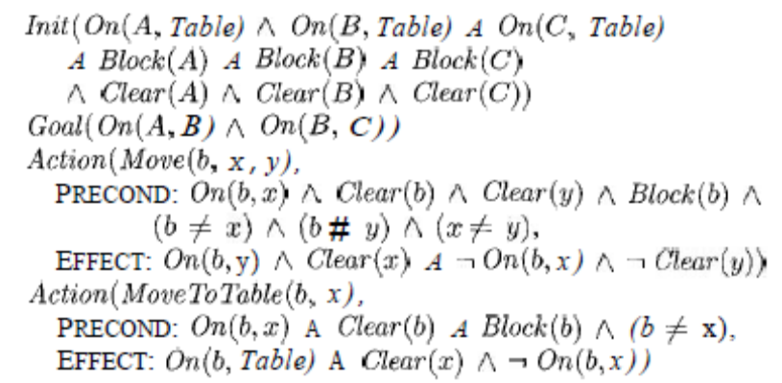

A planning problem in the blocks world: building a three-block tower. One solution is the sequence
[Move (B, T able, C), M ove (A, Table, B)].
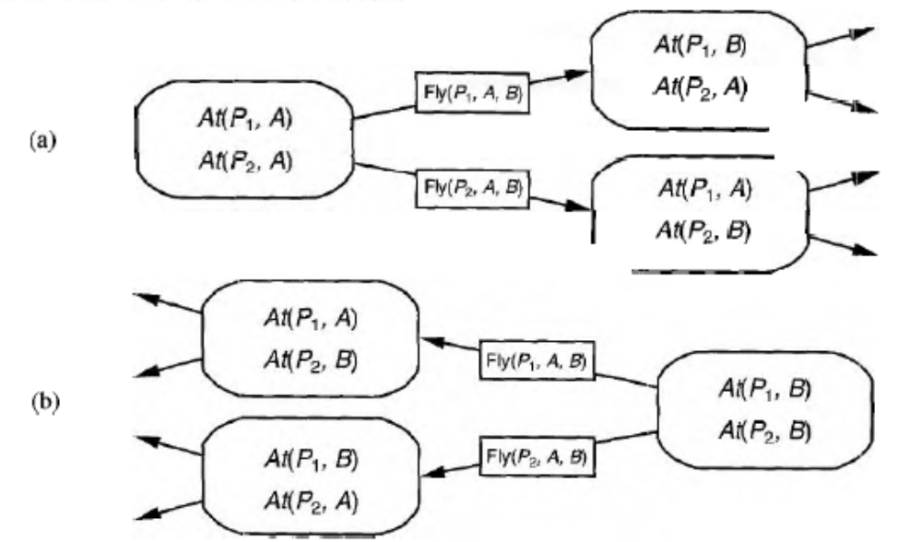
Two approaches to searching for a plan.
(a) Forward (progression) state-space search, starting in the initial state and using the problem's actions to search forward for the goal state.
(b) Backward (regression) state-space search: a belief-state search starting at the goal state(s) and using the inverse of the actions to search backward for the initial state.
We start in the problem's initial state, considering sequences of actions until we find a sequence that reaches a goal state. The formulation of planning problems as state-space search problems is as follows:
- The initial state of the search is the initial state from the planning problem.
- The actions that are applicable to a state are all those whose preconditions are satisfied. The successor state resulting from an action is generated by adding the positive effect literals and deleting the negative effect literals.
- The goal test checks whether the state satisfies the goal of the planning problem.
- The step cost of each action is typically 1. Although it would be easy to allow different costs for different actions, this is seldom done by STRIPS planners.
Recall that, in the absence of function symbols, the state space of a planning problem is finite.
Therefore, any graph search algorithm that is complete-for example, A*-will be a complete planning algorithm.
Example:
- Consider an air cargo problem with 10 airports, where each airport has 5 planes and 20 pieces of cargo.
- The goal is to move all the cargo at airport A to airport B.
- There is a simple solution to the problem: load the 20 pieces of cargo into one of the planes at A, fly the plane to B, and unload the cargo.
Backward state-space search
- Backward search can be difficult to implement when the goal states are described by a set of constraints rather than being listed explicitly.
- In particular, it is not always obvious how to generate a description of the possible predecessors of the set of goal states.
- The STRIPS representation makes this quite easy because sets of states can be described by the literals that must be true in those states.
- The main advantage of backward search is that it allows us to consider only relevant actions.
- An action is relevant to a conjunctive goal if it achieves one of the conjuncts of the goal.
For example, the goal in our 10-airport air cargo problem is to have 20 pieces of cargo at airport B, or more precisely,
At(C1,B ) ˄ At(C2,B )˄ . . . ˄ At(C20,B ).
- Now consider the conjunct At (C1B,).Working backwards, we can seek actions that have this as an effect. There is only one: Unload (C1, p, B), where plane p is unspecified.
- A backward search that allows irrelevant actions will still be complete, but it will be much less efficient.
- If a solution exists, it will be found by a backward search that allows only relevant actions.
- The restriction to relevant actions means that backward search often has a much lower branching factor than forward search.
- For example, our air cargo problem has about 1000 actions leading forward from the initial state, but only 20 actions working backward from the goal.
- Searching backwards is sometimes called regression planning.
- The principal question in regression planning is this: what are the states from which applying a given action leads to the goal? Computing the description of these states is called regressing the goal through the action.
- To see how to do it, consider the air cargo example. We have the goal
and the relevant action Unload(C1,p,B, ) ,which achieves the first conjunct.
- Therefore, any predecessor state must include these preconditions: In (C1, p) ˄ At (p, B).
- Thus, the predecessor description is
- In addition to insisting that actions achieve some desired literal, we must insist that the actions not undo any desired literals. An action that satisfies this restriction is called consistent.
For example, the action Load (C2, p) would not be consistent with the current goal, because it would negate the literal At (C2, B).
- Given a goal description G, let A be an action that is relevant and consistent. The corresponding predecessor is as follows:
- Any positive effects of A that appear in G are deleted.
- Each precondition literal of A is added, unless it already appears. In the first-order case, satisfaction might require a substitution for variables in the predecessor description. for example, the predecessor description in the preceding paragraph is satisfied by the initial state.
with substitution {p/P12}The substitution must be applied to the actions leading from the state to the goal, producing the solution [ Unload (Cl, P12, B)].
Heuristics for state-space search
- A heuristic function estimates the distance from a state to the goal; in STRIPS planning, the cost of each action is 1, so the distance is the number of actions.
- The basic idea is to look at the effects of the actions and at the goals that must be achieved and to guess how many actions are needed to achieve all the goals.
- Finding the exact number is NP hard, but it is possible to find reasonable estimates most of the time without too much computation.
- We might also be able to derive an admissible heuristic-one that does not overestimate.
- This could be used with A* search to find optimal solutions.
There are two approaches that can be tried.
- The first is to derive a relaxed problem from the given problem specification. The optimal solution cost
for the relaxed problem-which we hope is very easy to solve-gives an admissible heuristic for the original problem.
- The second approach is to pretend that a pure divide-and-conquer algorithm will work.
- This is called the subgoal independence assumption: the cost of solving a conjunction of subgoals is approximated by the sum of the costs of solving each subgoal independently.
- The subgoal independence assumption can be optimistic or pessimistic.
- It is optimistic when there are negative interactions between the subplans for each subgoal for example, when an action in one subplan deletes a goal achieved by another subplan.
- It is pessimistic, and therefore inadmissible, when subplans contain redundant actions-for instance, two actions that could be replaced by a single action in the merged plan.
Let us consider how to derive relaxed planning problems.
- The simplest idea is to relax the problem by removing all preconditions from the actions.
- Then every action will always be applicable, and any literal can be achieved in one step (if there is an applicable action-if not, the goal is impossible).
- This almost implies that the number of steps required to solve a conjunction of goals is the number of unsatisfied goals-almost but not quite, because
(1) There may be two actions, each of which deletes the goal literal achieved by the other, and
(2) some action may achieve multiple goals.
In many cases, a more accurate heuristic is obtained by considering at least the positive interactions arising from actions that achieve multiple goals.
- First, we relax the problem further by removing negative effects. Then, we count the minimum number of actions required such that the union of those actions' positive effects satisfies the goal.
- For example, consider
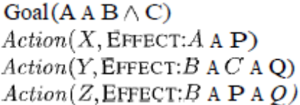
- The minimal set cover of the goal {A, B, C) is given by the actions {X, Y), so the set cover heuristic returns a cost of 2. This improves on the subgoal independence assumption, which gives a heuristic value of 3.
- It is also possible to generate relaxed problems by removing negative effects without removing preconditions.
- That is, if an action has the effect A ˄ ⌐B in the original problem, it will have the effect A in the relaxed problem.
- This means that we need not worry about negative interactions between subplans, because no action can delete the literals achieved by another action.
- The solution cost of the resulting relaxed problem gives what is called the empty-delete-list heuristic.
PARTIAL – ORDER PLANNING
- Forward and backward state-space search are particular forms of totally ordered plan search.
- They explore only strictly linear sequences of actions directly connected to the start or goal. This means that they cannot take advantage of problem decomposition.
- We would prefer an approach that works on several sub goals independently, solves them with several sub plans, and then combines the sub plans.
- Such an approach also has the advantage of flexibility in the order in which it constructs the plan. That is, the planner can work on "obvious" or "important “decisions first, rather than being forced to work on steps in chronological order.
The general strategy of delaying a choice during search is called a least commitment strategy. Despite the informality, least commitment is a useful concept for analyzing when decisions should be made in any search problem.
Example:
Consider the simple problem of putting on a pair of shoes. We can describe this as a formal planning problem as follows:
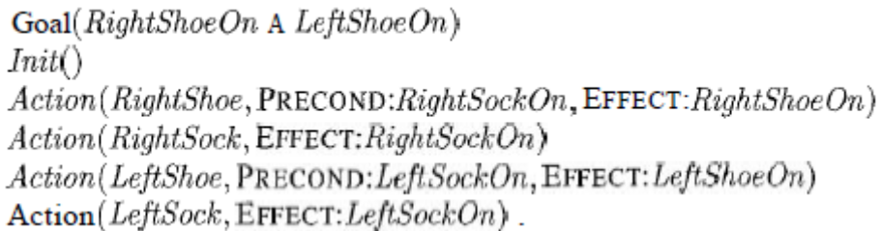
- A planner should be able to come up with the two-action sequence Rightsock followed by Rightshoe to achieve the first conjunct of the goal and the sequence Leftsock followed by LeftShoe for the second conjunct. Then the two sequences can be combined to yield the final plan.
Partial-order planner:
- In doing this, the planner will be manipulating the two subsequences independently, without committing to whether an action in one sequence is before or after an action in the other. Any planning algorithm that can place two actions into a plan without specifying which comes first is called a partial-order planner.
- The solution is represented as a graph of actions, not a sequence.
- The "dummy" actions called Start and Finish, which mark the beginning and end of the plan.
- Calling them actions simplifies things, because now every step of a plan is an action. The partial-order solution corresponds to six possible total-order plans; each of these is called a linearization of the partial-order plan.
- Partial-order planning can be implemented as a search in the space of partial-order plans.
- That is, we start with an empty plan.Then we consider ways of refining the plan until we come up with a complete plan that solves the problem. The actions in this search are not actions in the world, but actions on plans: adding a step to the plan, imposing an ordering that puts one action before another, and so on.
Each plan has the following four components, where the first two define the steps of the plan and the last two serve a bookkeeping function to determine how plans can be extended
- A set of actions that make up the steps of the plan. These are taken from the set of actions in the planning problem. The "empty" plan contains just the Start and Finish actions. Start has no preconditions and has as its effect all the literals in the initial state of the planning problem. Finish has no effects and has as its preconditions the goal literals of the planning problem.
- A set of ordering constraints. Each ordering constraint is of the form A B, which is read as "A before B" and means that action A must be executed sometime before action B, but not necessarily immediately before. Any cycle-such as A B and B A-represents a contradiction, so an ordering constraint cannot be added to the plan if it creates a cycle.
- A set of causal links. A causal link between two actions A and B in the plan is written as A B and is read as "A achieves p for B."
- For example, the causal link
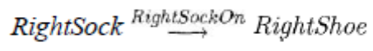
asserts that RightSockOn is an effect of the RightSock action and a precondition of RightShoe.
- It also asserts that RightSockOn must remain true from the time of action RightSock to the time of action RightShoe.
- In other words, the plan may not be extended by adding a new action C that conflicts with the causal link.
- An action C conflicts with A B if C has the effect ⌐p and if C could come after A and before B.
- Some authors call causal links protection intervals, because the link A B protects p from being negated over the interval from A to B.
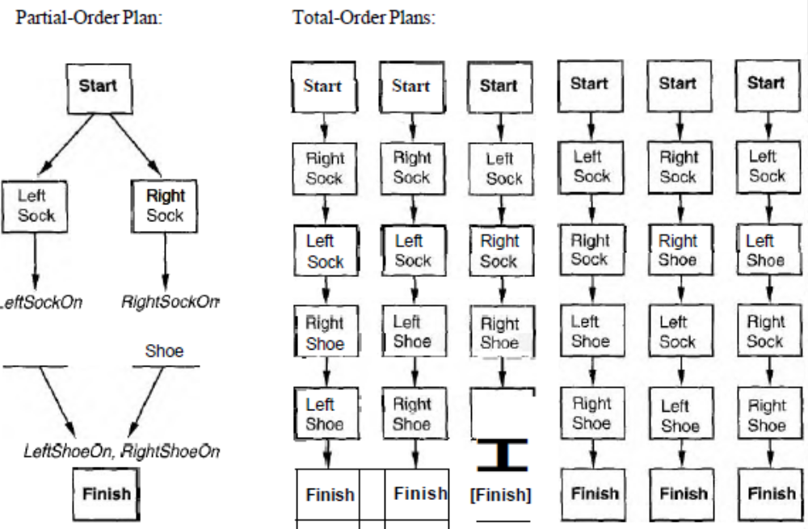
Fig: A partial-order plan for putting on shoes and socks, and the six corresponding linearization into total-order plans.
- A set of open preconditions. A precondition is open if it is not achieved by some action in the plan. Planners will work to reduce the set of open preconditions to the empty set, without introducing a contradiction.
The final plan in Fig has the following components,
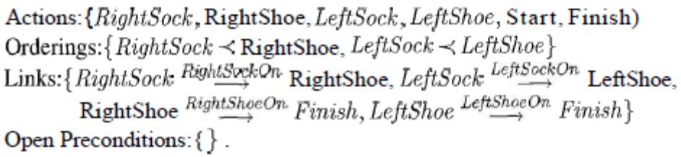
Consistent Plan:
- We define a consistent plan as a plan in which there are no cycles in the ordering constraints and no conflicts with the causal links.
- A consistent plan with no open preconditions is a solution.
- A moment's thought should convince the reader of the following fact: every linearization of a partial-order solution is a total-order solution whose execution from the initial state will reach a goal state.
- This means that we can extend the notion of "executing a plan" from total-order to partial-order plans.
- A partial-order plan is executed by repeatedly choosing any of the possible next actions.
- The flexible ordering also makes it easier to combine smaller plans into larger ones, because each of the small plans can reorder its actions to avoid conflict with the other plans.
The definition includes the initial state, actions, and goal test.
The initial plan contains Start and Finish, the ordering constraint Start Finish, and no causal links and has all the preconditions in Finish as open preconditions.
- The successor function arbitrarily picks one open precondition p on an action B and generates a successor plan for every possible consistent way of choosing an action A that achieves p.
Consistency is enforced as follows:
- The causal link A B and the ordering constraint A B are added to the plan. Action A may be an existing action in the plan or a new one. If it is new, add it to the plan and also add Start A and A Finish.
- We resolve conflicts between the new causal link and all existing actions and between the action A (if it is new) and all existing causal links. A conflict between A B and C is resolved by making C occur at some time outside the protection interval, either by adding B C or C A. We add successor states for either or both if they result in consistent plans.
- The goal test checks whether a plan is a solution to the original planning problem. Because only consistent plans are generated, the goal test just needs to check that there are no open preconditions.
- Nonetheless, it is possible to specify a path cost function that reflects the real plan costs: we charge 1 for each real action added to the plan and 0 for all other refinement steps. g(n), where n is a plan, will be equal to the number of real actions in the plan. A heuristic estimate h(n) can also be used.
- At first glance, one might think that the successor function should include successors for every open p, not just for one of them. This would be redundant and inefficient.
- Thus, we can choose an arbitrary ordering and still have a complete algorithm. Choosing the right ordering can lead to a faster search, but all orderings end up with the same set of candidate solutions.
PLANNING GRAPHS:
- All of the heuristics we have suggested for total-order and partial-order planning can suffer from inaccuracies. This section shows how a special data structure called a planning graph can be used to give better heuristic estimates.
- Alternatively, we can extract a solution directly from the planning graph, using a specialized algorithm such as the one called GRAPHPLAN.
- A planning graph consists of a sequence of levels that correspond to time steps in the plan, where level 0 is the initial state. Each level contains a set of literals and a set of actions.
- The planning graph records only a restricted subset of the possible negative interactions among actions; therefore, it might be optimistic about the minimum number of time steps required for a literal to become true.
- Nonetheless, this number of steps in the planning graph provides a good estimate of how difficult it is to achieve a given literal from the initial state.
- The planning graph is defined in such a way that it can be constructed very efficiently.
- Planning graphs work only for propositional planning problems-ones with no variables.
- For problems with large numbers ad objects, this could result in a very substantial blowup in the number of action schemata. Despite this, planning graphs have proved to be effective tools for solving hard planning problems.
Example:
- We start with state level So, which represents the problem's initial state. We follow that with action level Ao, in which we place all the actions whose preconditions are satisfied in the previous level.
- Each action is connected to its preconditions in So and its effects in S1, in this case introducing new literals into, S1 that were not in So.
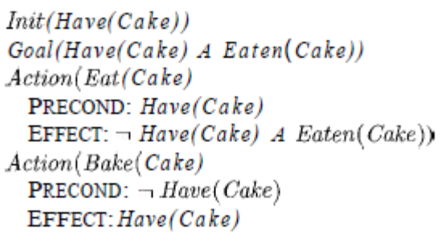
Figure: The "have cake and eat cake too'' problem.
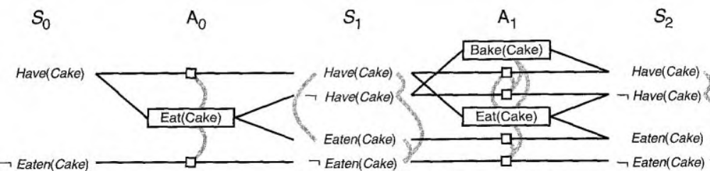

Figure: The planning graph for the "have cake and eat cake too" problem up to level S2. Rectangles indicate actions (small squares indicate persistence actions) and straight lines indicate preconditions and effects. Mutex links are shown as curved gray lines.
- The planning graph needs a way to represent inaction as well as action. In a planning graph this is done with a set of persistence actions. For every positive and negative literal C, we add to the problem a persistence action with precondition C and effect C.
- Shows one "real" action, Eat(Cake) in Ao, along with two persistence actions drawn as small square boxes.
Mutual exclusion (or mutex) links:
- Level Ao. contains all the actions that could occur in state So, but just as importantly it records conflicts between actions that would prevent them from occurring together. The gray lines in Figure indicate mutual exclusion (or mutex) links.
- For example, Eat(Cake) is mutually exclusive with the persistence of either
Have (Cake) or ⌐Eaten (Cake).
- Level S1 contains all the literals that could result from picking any subset of the actions in Ao.
- It also contains mutex links (gray lines) indicating literals that could not appear together, regardless of the choice of actions.
- For example, Have (Cake) and Eaten (Cake) are mutex: depending on the choice of actions in Ao, one or the other, but not both, could be the result. In other words, S₁ represents multiple states, just as regression state-space search does, and the mutex links are constraints that define the set of possible states.

Leveled off:
- We continue in this way, alternating between state level S_{i} and action level A_{i}, until we reach a level where two consecutive levels are identical. At this point, we say that the graph has leveled off.
- A structure where every A_{i} level contains all the actions that are applicable in S_{i}, along with constraints saying which pairs of actions cannot both be executed. Every S_{i}, level contains all the literals that could result from any possible choice of actions in A_{i-1}, along with constraints saying which pairs of literals are not possible.
- The complexity of constructing the planning graph is a low-order polynomial in the number of actions and literals, whereas the state space is exponential in the number of literals.
- We now define mutex links for both actions and literals. A mutex relation holds between two actions at a given level if any of the following three conditions holds:
- Inconsistent effects: one action negates an effect of the other. For example Eat (Cake) and the persistence of Have (Cake) have inconsistent effects because they disagree on the effect Have (Cake).
- Interference: one of the effects of one action is the negation of a precondition of the other. For example Eat (Cake) interferes with the persistence of Have (Cake) by negating its precondition.
- Competing needs: one of the preconditions of one action is mutually exclusive with a precondition of the other. For example, Bake (Cake) and Eat (Cake) are mutex because they compete on the value of the
Have (Cake) precondition.
- A mutex relation holds between two literals at the same level if one is the negation of the other r if each possible pair of actions that could achieve the two literals is mutually exclusive. This condition is called inconsistent support.
- For example, Have(Cake) and Eaten(Cake) are mutex in S₁ because the only way of achieving
Have (Cake), the persistence action, is mutex with the only way of achieving Eaten (Cake), namely Eat (Cake).
- In S2 the two literals are not mutex because there are new ways of achieving them, such as Bake (Cake) and the persistence of Eaten (Cake), that are not mutex.
Planning graphs for heuristic estimation:
- A planning graph, once constructed, is a rich source of information about the problem. For example, a literal that does not appear in the final level of the graph cannot be achieved by any plan.
- This observation can be used in backward search as follows: any state containing an unachievable literal has a cost h(n) = ∞. Similarly, in partial-order planning, any plan with an unachievable open condition has h(n) = ∞.
- We can estimate the cost of achieving any goal literal as the level at which it first appears in the planning graph. We will call this the level cost of the goal. In Figure Have (Cake) has level cost 0 and Eaten (Cake) has level cost 1.
- The estimate might not be very good, however, because planning graphs allow several actions at each level whereas the heuristic counts just the level and not the number of actions. For this reason, it is common to use a serial planning graph for computing heuristics.
- A serial graph insists that only one action can actually occur at any given time step; this is done by adding mutex links between every pair of actions except persistence actions.
To estimate the cost of a conjunction of goals, there are three simple approaches.
- The max-level heuristic simply takes the maximum level cost of any of the goals; this is admissible, but not necessarily very accurate.
- The level sum heuristic, following the subgoal independence assumption, returns the sum of the level costs of the goals; this is inadmissible but works very well in practice for problems that are largely decomposable.
For our problem, the heuristic estimate for the conjunctive goal Have (Cake) A Eaten (Cake) will be 0 + 1 = 1, whereas the correct answer is 2. Moreover, if we eliminated the Bake (Cake) action, the estimate would still be 1, but the conjunctive goal would be impossible.
- The set-level heuristic finds the level at which all the literals in the conjunctive goal appear in the planning graph without any pair of them being mutually exclusive. This heuristic gives the correct values of 2 for our original problem and infinity for the problem without Bake (Cake).
- We can view the planning graph as a relaxed problem that is efficiently soluble.
- Ideally, we would like it to be a guarantee that there exists a plan with i action levels that achieves g, and also that if g does not appear that there is no such plan.
- Unfortunately, making that guarantee is as difficult as solving the original planning problem. So the planning graph makes the second half of the guarantee (if g does not appear, there is no plan), but if g does appear, then all the planning graph promises is that there is a plan that possibly achieves g and has no "obvious" flaws.
- An obvious flaw is defined as a flaw that can be detected by considering two actions or two literals at a time-in other words, by looking at the mutex relations.
- There could be more subtle flaws involving three, four, or more actions, but experience has shown that it is not worth the computational effort to keep track of these possible flaws.
The GRAPHPLAN algorithm
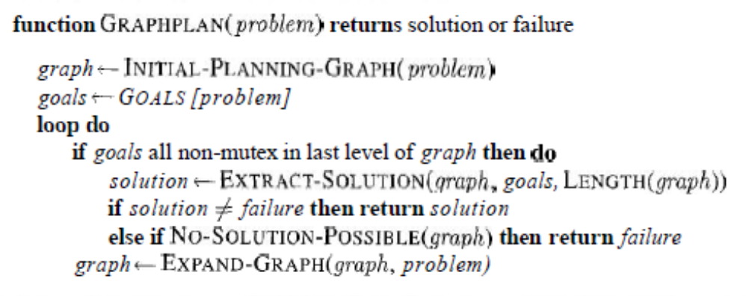
Figure 1: The GRAPHPLAN algorithm.
- GRAPHPLAN alternates between a solution extraction step and a graph expansion step. EXTRACT-SOLUTION looks for whether a plan can be found, starting at the end and searching backwards.
- EXPAND-GRAPH adds the actions for the current level and the state literals for the next level.
- The GRAPHPLAN algorithm (Figure 1) has two main steps, which alternate within a loop.
- First, it checks whether all the goal literals are present in the current level with no mutex links between any pair of them. If this is the case, then a solution might exist within the current graph, so the algorithm tries to extract that solution.
- Otherwise, it expands the graph by adding the actions for the current level and the state literals for the next level. The process continues until either a solution is found or it is learned that no solution exists.
- The first line of GRAPHPLAN initializes the planning graph to a one-level (So) graph consisting of the five literals from the initial state.
- The goal literal At(Spare, Axle) is not present in So, so we need not call EXTRACT-SOLUTION-we are certain that there is no solution yet.
- Instead, EXPAND-GRAPH adds the three actions whose preconditions exist at level So (i.e., all the actions except PutOn(Spare, Axle)), along with persistence actions for all the literals in So.
- The effects of the actions are added at level S1. EXPAND-GRAPH then looks for mutex relations and adds them to the graph.
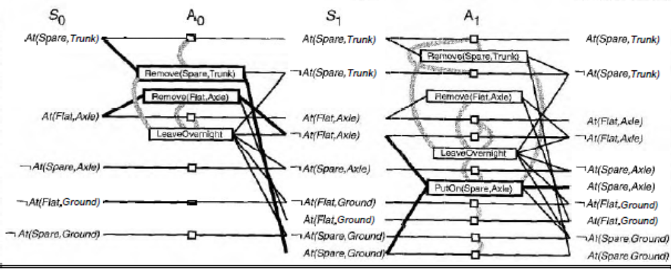
Figure 2: The planning graph for the spare tire problem after expansion to level S2.
- Mutex links are shown as gray lines. Only some representative mutexes are shown, because the graph would be too cluttered if we showed them all.
- The solution is indicated by bold lines and outlines.
At(Spare, Axle) is still not present in S1, so again we do not call EXTRACT-SOLUTION.
The call to EXPAND-GRAPH gives us the planning graph shown in Figure 2. Now that we have the full complement of actions, it is worthwhile to look at some of the examples of mutex relations and their causes:
Inconsistent effects: Remove (Spare, Trunk) is mutex with LeaveOvernight because one has the effect At (Spare, Ground) and the other has its negation.
Interference: Remove (Flat, Axle) is mutex with LeaveOvernight because one has the precondition At(Flat, Ade) and the other has its negation as an effect.
Competing needs: Put On (Spare, Axle) is mutex with Remove (Flat, Axle) because one has At (Flat, Axle) as a precondition and the other has its negation.
Inconsistent support: At(Spare, Axle) is mutex with At(Flat, Axle) in S2 because the only way of achieving At(Spare, Axle) is by PutOn(Spare, Axle), and that is mutex with the persistence action that is the only way of achieving At(Flat, Axle).
Thus, the mutex relations detect the immediate conflict that arises from trying to put two objects in the same place at the same time.
- We can use standard CSP algorithms for this, or we can define EXTRACT-SOLUTION as a search problem, where each state in the search contains a pointer to a level in the planning graph and a set of unsatisfied goals.
- We define this search problem as follows:
- The initial state is the last level of the planning graph, S,, along with the set of goals from the planning problem.
- The actions available in a state at level Si are to select any conflict-free subset of the actions in Ai-1 whose effects cover the goals in the state.
- The resulting state has level Si-1 and has as its set of goals the preconditions for the selected set of actions. By "conflict-free," we mean a set of actions such that no two of them are mutex, and no two of their preconditions are mutex.
- The goal is to reach a state at level So such that all the goals are satisfied.
- The cost of each action is 1.
- For this particular problem, we start at S2 with the goal At (Spare, Axle).
- The only choice we have for achieving the goal set is PutOn (Spare, Axle).
- That brings us to a search state at S1 with goals At (Spare, Ground) and 1At (Flat, Axle).
- The former can be achieved only by Remove (Spare, Trunk), and the latter by either Remove (Flat, Axle) or LeaveOvernight.
- But Leaveovernight is mutex with Remove (Spare, Trunk), so the only solution is to choose Remove (Spare, Trunk) and Remove (Flat, Axle).
- That brings us to a search state at So with the goals At (Spare, Trunk) and At (Flat, Axle).
- Both of these are present in the state, so we have a solution: the actions Remove (Spare, Trunk) and Remove (Flat, Axle) in level Ao, followed by PutOn (Spare, Axle) in A_{1.}
Termination of GRAPHPLAN:
- So far, we have skated over the question of termination.
- If a problem has no solution, can we be sure that GRAPHPLAN will not loop forever, extending the planning graph at each iteration?
- The answer is yes, but the full proof is beyond the scope of this book.
- Here, we outline just the main ideas, particularly the ones that shed light on planning graphs in general.
- The first step is to notice that certain properties of planning graphs are monotonically increasing or decreasing. "X increases monotonically" means that the set of Xs at level i+1 is a superset (not necessarily proper) of the set at level i.
- The properties are as follows:
Literals increase monotonically: Once a literal appears at a given level, it will appear at all subsequent levels. This is because of the persistence actions; once a literal shows up, persistence actions cause it to stay forever.
Actions increase monotonically: Once an action appears at a given level, it will appear at all subsequent levels. This is a consequence of literals' increasing; if the preconditions of an action appear at one level, they will appear at subsequent levels, and thus so will the action.
Mutexes decrease monotonically: If two actions are mutex at a given level Ai, then they will also be mutex for all previous levels at which they both appear.
- The same holds for mutexes between literals.
- It might not always appear that way in the figures, because the figures have a simplification: they display neither literals that cannot hold at level Si nor actions that cannot be executed at level Ai.
- We can see that "mutexes decrease monotonically" is true if you consider that these invisible literals and actions are mutex with everything.
The proof is a little complex, but can be handled by cases:
if actions A and B are mutex at level Ai, it must be because of one of th'e three types of mutex.
1.The first two, inconsistent effects and interference, are properties of the actions themselves, so if the actions are mutex at Ai, they will be mutex at every level.
- The third case, competing needs, depends on conditions at level Si: that level must contain a precondition of A that is mutex with a precondition of B.
- Now, these two preconditions can be mutex if they are negations of each other (in which case they would be mutex in every level) or if all actions for achieving one are mutex with all actions :for achieving the other.
- But we already know that the available actions are increasing monotonically, so by induction, the mutexes must be decreasing.
- Because the actions and literals increase and the mutexes decrease, and because there are only a finite number of actions and literals, every planning graph will eventually level off-all subsequent levels will be identical.
- Once a graph has leveled off, if it is missing one of the goals of the problem, or if two of the goals are mutex, then the problem can never be solved, and we can stop the GRAPHPLAN algorithm and return failure.
- If the graph levels off with all goals present and nonmutex, but EXTRACT-SOLUTION fails to find a solution, then we might have to extend the graph again a finite number of times, but eventually we can stop.
HIERARCHICAL TASK NETWORK PLANNING:
- One of the most pervasive ideas for dealing with complexity is hierarchical decomposition.
- Complex software is created from a hierarchy of subroutines or object classes, armies operate as a hierarchy of units, governments and corporations have hierarchies of departments, subsidiaries, and branch offices.
- The key benefit of hierarchical structure is that, at each level of the hierarchy, a computational task,
military mission, or administrative function is reduced to a small number of activities at the next lower level, so that the computational cost of finding the correct way to arrange those activities for the current problem is small.
Hierarchical Task Networks:
- In HTN planning, the initial plan, which describes the problem, is viewed as a very high-level description of what is to be done-for example, building a house. Plans are refined by applying action decompositions.
- Each action decomposition reduces a high-level action to a partially ordered set of lower-level actions.
- For example, building a house might be reduced to obtaining a permit, hiring a contractor, doing the construction, and paying the contractor. (Figure shows such decomposition.)
- The process continues until only primitive actions remain in the plan. Typically, the primitive actions will be actions that the agent can execute automatically.
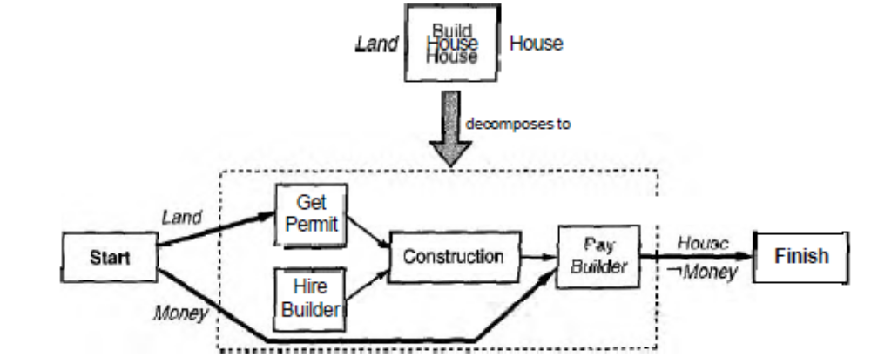
Figure 1: One possible decomposition for the BuildHouse action
Representing action decompositions:
- General descriptions of action decomposition methods are stored in a plan library, from which they are extracted and instantiated to fit the nee~dso f the plan being constructed.
- Each method is an expression of the form Decompose (a, d). This says that an action a can be decomposed into the plan d, which is represented as a partial-order plan.
- Building a house is a nice, concrete example, so we will use it to illustrate the concept of action decomposition. Figure 1 depicts one possible decomposition of the BuildHouse action into four lower-level actions. Figure 2 shows some of the action descriptions for the domain, as well as the decomposition for BuildHouse as it would appear in the plan library.
- The Start action of the decomposition supplies all those preconditions of actions in the plan that are not supplied by other actions. We call these the external preconditions.
- In our example, the external preconditions of the decompositions are Land and Money. Similarly, the external effects, which are the preconditions of Finish, are all those effects of actions in the plans that are not negated by other actions.
- In our example, the external effects of BuildHouse are House and ⌐Money. Some HTN planners also distinguish between primary effects, such as House, and secondary effects, such as ⌐Money.
- Only primary effects may be used to achieve goals, whereas both kinds of effects might cause conflicts with other actions; this can greatly reduce the search space.
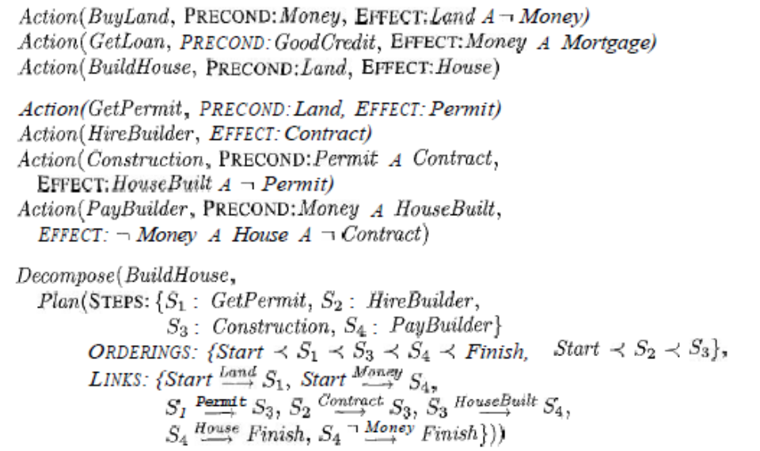
Figure 2: Action descriptions for the house-building problem and a detailed decomposition for the BuildHouse action. The descriptions adopt a simplified view of money and an optimistic view of builders.
- Decomposition should be a correct implementation of the action. A plan d implements an action a correctly if d is a complete and consistent partial-order plan for the problem of achieving the effects of a given the preconditions of a.
- A plan library could contain several decompositions for any given high-level action; for example, there might be decomposition for BuildHouse that describes a process whereby the agent builds a house from rocks and turf with its own bare hands.
- Each decomposition should be a correct plan, but it could have additional preconditions and effects beyond those stated in the high-level action description.
- For example, the decomposition for BuzldHouse in Figure 1 requires Money in addition to Land and has the effect ⌐Money. The self-build option, on the other hand, doesn't require money, but does require a ready supply of Rocks and Turf, and could result in a BadBack.
Internal effects:
- Two other forms of information hiding should be noted.
- First, the high-level description completely ignores all internal effects of the decompositions. For example, our BuildHouse decomposition has temporary internal effects Permit and Construct.
- Second, the high-level description does not specify the intervals "inside" the activity during which the high-level preconditions and effects must hold. For example, the Land precondition needs to be true (in our very approximate model) only until Getpermit is performed, and House is true only after PayBuilder is performed.
- Information hiding of this kind is essential if hierarchical planning is to reduce complexity; we need to be able to reason about high-level actions without worrying about myriad details of the implementations.
Modifying the planner for decompositions:
- We do that by modifying the POP successor function to allow decomposition methods to be applied to the current partial plan P.
- The new successor plans are formed by first selecting some nonprimitive action a' in P and then, for any Decompose (a, d) method from the plan library such that a and a' unify with substitution Ѳ, replacing a' with d' = SUBST (Ѳ, d).
- At the top, there is a plan P for getting a house. The high-level action, a' = BuildHouse, is selected for decomposition. The decomposition d is selected from Figure 1 and BuildHouse is replaced by this decomposition.
- An additional step, GetLoan, is then introduced to resolve the new open condition, Money that is created by the decomposition step. Replacing an action with its decomposition is a bit like transplant surgery: we have to take the new subplan out of its packaging (the Start and Finish steps), insert it, and hook everything up properly.
- There might be several ways to do this.
To be more precise, we have for each possible decomposition d',
- First, the action a' is removed from P. Then, for each step s in the decomposition d', we need to choose an action to fill the role of s and add it to the plan. It can be either a new instantiation of s or an existing step s’ from P that unifies with s.
- For example, the decomposition of a Make Wine action might suggest that we BuyLand; possibly, we can use the same BuyLand action that we already have in the plan. We call this subtask sharing.
- The next step is to hook up the ordering constraints for a' in the original plan to the steps in d'.
- First, consider an ordering constraint in P of the form B a'. How should B be ordered with respect to the steps in d'?
- The most obvious solution is that B should come before every step in d', and that can be achieved by replacing every constraint of the form Start s in d' with a constraint B s.
- On the other hand, this approach might be too strict! For example, BuyLand has to come before BuildHouse, but there is no need for BuyLand to come before HireBuilder in the expanded plan.
- Imposing an overly strict ordering might prevent some solutions from being found.
- Therefore, the best solution is for each ordering constraint to record the reason for the constraint; then, when a high-level action is expanded, the new ordering constraints can be as relaxed as possible, consistent with the reason for the original constraint.
- Exactly the same considerations apply when we are replacing constraints of the form a' C.
- The final step is to hook up causal links. If B a' was a causal link in the original plan, replace it by a set of causal links from B to all the steps in dl with preconditions p that were supplied by the Start step in the decomposition d (i.e., to all the steps in d' for which p is an external precondition).
- In the example, the causal link BuyLand BuildHouse is replaced by the link
BuyLand Permit. (The Money precondition for PayBuilder in the decomposition becomes an open condition, because no action in the original plan supplies Money to BuildHouse.)
- Similarly, for each causal link a' C in the plan, replace it with a set of causal links to C from whichever step in d^{t} supplies p to the Finish step in the decomposition d (i.e., from the step in dl that has p as an external effect).
- In the example, we replace the: link BuildHouse Finish with the link
PayBuilder Finish.
Additional modifications to the POP algorithm are required because of the fact that high-level actions hide information about their final primitive implementations. With high-level actions, on the other hand, apparently irresolvable conflicts can sometimes be resolved by decomposing the conflicting actions and interleaving their steps.
PLANNING AND ACTING IN NONDETERMINISTIC DOMAINS:
So far we have considered only classical planning domains that are fully observable, static, and deterministic.
- Furthermore, we have assumed that the action descriptions are correct and complete.
- In these circumstances, an agent can plan first and then execute the plan "with its eyes closed."
- In an uncertain environment, on the other hand, an agent must use its percepts to discover what is happening while the plan is being executed and possibly modify or replace the plan if something unexpected happens.
- Agents have to deal with both incomplete and incorrect information.
- Incompleteness arises because the world is partially observable, nondeterministic, or both.
- Incorrectness arises because the world does not necessarily match my model of the world.
- The possibility of having complete or correct knowledge depends on how much indeter-minacy there is in the world.
- With bounded indeterminacy, actions can have unpredictable effects, but the possible effects can be listed in the action description axioms.
- For example, when we flip a coin, it is reasonable to say that the oiltcome will be Heads or Tails.
- An agent can cope with bounded indeterminacy by making plans that work in all possible circumstances.
- With unbounded indeterminacy, the set of possible preconditions or effects either is unknown or is too large to be enumerated completely.
- This would be the case in very complex or dynamic domains such as driving, economic planning, and military strategy.
- An agent can cope with unbounded indeterminacy only if it is prepared to revise its plans andfor its knowledge base.
There are four planning methods for handling indeterminacy. The first two are suitable for bounded indeterminacy, and the second two for unbounded indeterminacy:
- Sensorless planning: Also called conformant planning, this method constructs standard, sequential plans that are to be executed without perception.
- The Sensorless planning algorithm must ensure that the plan achieves the goal in all possible circumstances, regardless of the true initial state and the actual action outcomes.
- Sensorless planning relies on coercion-the idea that the world can be forced into a given state even when the agent has only partial information about the current state.
- Conditional planning: Also known as contingency planning, this approach deals with bounded indeterminacy by constructing a conditional plan with different branches for the different contingencies that could arise.
- Just as in c1assical planning, the agent plans first and then executes the plan that was produced.
- The agent finds out which part of the plan to execute by including sensing actions in the plan to test for the appropriate conditions.
- Execution monitoring and replanning: In this approach, the agent can use any of the preceding planning techniques (classical, Sensorless, or conditional) to construct a plan, but it also uses execution monitoring to judge whether the plan has a provision for the actual current situation or need to be revised.
- Replanning occurs when something goes wrong.
- Continuous planning: All the planners we have seen so far are designed to achieve a goal and then stop.
- A continuous planner is designed to persist over a lifetime.
- It can handle unexpected circumstances in the environment, even if these occur while the agent is in the middle of constructing a plan.
An example to clarify the differences among the various kinds of agents.
The problem is this: given an initial state with a chair, a table, and some cans of paint, with everything of unknown color, achieve the state where the chair and table have the same color.
- A classical planning agent could not handle this problem, because the initial state is not fully specified-we don't know what color the furniture is.
- A Sensorless planning agent must find a plan that works without requiring any sensors during plan execution.
- The solution is to open any can of paint and apply it to both chair and table, thus coercing them to be the same color (even though the agent doesn't know what the color is).
- Coercion is most appropriate when propositions are expensive or impossible to perceive.
- A conditional planning agent can generate a better plan: first sense the color of the table and chair; if they are already the same then the plan is done.
- If not, sense the labels on the paint cans; if there is a can that is the same color as one piece of furniture, then apply the paint to the other piece.
- Otherwise paint both pieces with any color.
- A replanning agent could generate the same plan as the conditional planner, or it could generate fewer branches at first and fill in the others at execution time as needed.
- It could also deal with incorrectness of its action descriptions.
- A continuous planning agent, in addition to handling unexpected events, can revise its plans appropriately if, say, we add the goal of having dinner on the table, so that the painting plan must be postponed.

- In general, agents create conditional plans only for those contingencies that have important consequences and a non negligible chance of going wrong.
- Thus, a car driver contemplating a trip across the Sahara desert might do well to consider explicitly the possibility of breakdowns, whereas a trip to the supermarket requires less advance planning.
EXECUTION MONITORING AND REPLANNING:
- An execution monitoring agent checks its percepts to see whether everything is going according to plan.
- The problem is unbounded indeterminacy-some unanticipated circumstance will always arise for which the agent's actions descriptions are incorrect.
- Therefore, execution monitoring is a necessity in realistic environments.
- We will consider two kinds of execution monitoring: a simple, but weak form called action monitoring, whereby the agent checks the environment to verify that the next action will work.
- A more complex but more effective form called plan monitoring, in which the agent verifies the entire remaining plan.
- A replanning agent knows what to do when something unexpected happens: call a planner again to come up with a new plan to reach the goal.
- To avoid spending too much time planning, this is usually done by trying to repair the old plan-to find a way from the current unexpected state back onto the plan.
- If no dirt is dumped on arrival when the plan is actually executed, then the agent will detect the achievement of the goal.
- Otherwise, because the CleanL precondition of the implicit Finish step is not satisfied, the agent will generate a new plan: [Suck]. Execution of this plan always succeeds.
- Together, execution monitoring and replanning form a general strategy that can be applied to both fully and partially observable environments, and to a variety of planning representations including state-space, partial-order, and conditional plans.
- The planning agent starts with a goal and creates an initial plan to achieve it.
- The agent then starts executing actions one by one.
- The replanning agent, unlike our other planning agents, keeps track of both the remaining unexecuted plan segment plan and the complete original plan whole-plan.
- It uses action monitoring: before carrying out the next action of plan, the agent examines its percepts to see whether any preconditions of the plan have unexpectedly become unsatisfied.
Figure 1 provides a schematic illustration of the process.
- The replanner notices that the preconditions of the first action in plan are not satisfied by the current state.
- It then calls the planner to come up with a new subplan called repair that will get from the current situation to some state s on whole-plan.
- The concatenation of repair and the portion of whole-plan from s onward, which we call continuation,
makes up the new plan, and the agent is ready to resume execution.

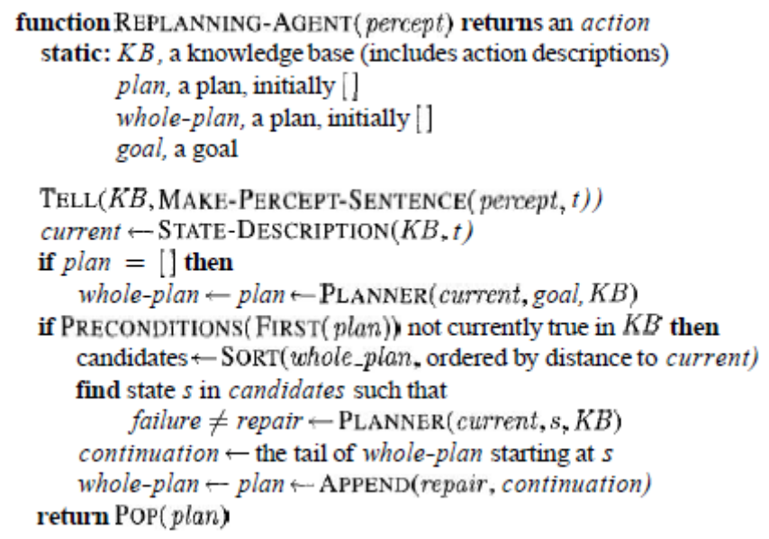
Figure 1: An agent that does action monitoring and replanning.
- It uses a complete state-space planning algorithm called PLANNER as a subroutine.
- If the preconditions of the next action are not met, the agent loops through the possible points p in whole-plan, trying to find one that PLANNER can plan a path to. This path is called repair.
- If PLANNER succeeds in finding a repair, the agent appends repair and the tail of the plan after p, to create the new plan. The agent then returns the first step in the plan.
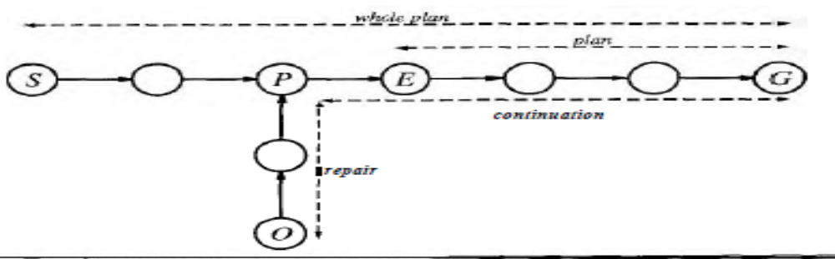
Figure 2: Before execution, the planner comes up with a plan, here called whole-plan, to get from S to G.
- The agent executes the plan until the point marked E.
- Before executing the remaining plan, it checks preconditions as usual and finds that it is actually in state 0 rather than state E.
- It then calls its planning algorithm to come up with repair, which is a plan to get from 0 to some point P on the original whole-plan.
- The new plan now becomes the concatenation of repair and continuation (the resumption of the original whole-plan).
- The example problem of achieving a chair and table of matching color, this time via replanning.
- We'll assume a fully observable environment.
- In the initial state the chair is blue, the table is green, and there is a can of blue paint and a can of red paint.
That gives us the following problem definition:
- Now the agent is ready to execute the plan.
- But the execution monitoring agent must first check the precondition of the Finish step, which says that the two pieces must have the same color.
- The agent notices that the current state is identical to the precondition before the Paint action, so the agent chooses the empty sequence for repair and makes its plan be the same [Paint, Finish] sequence that it just attempted.
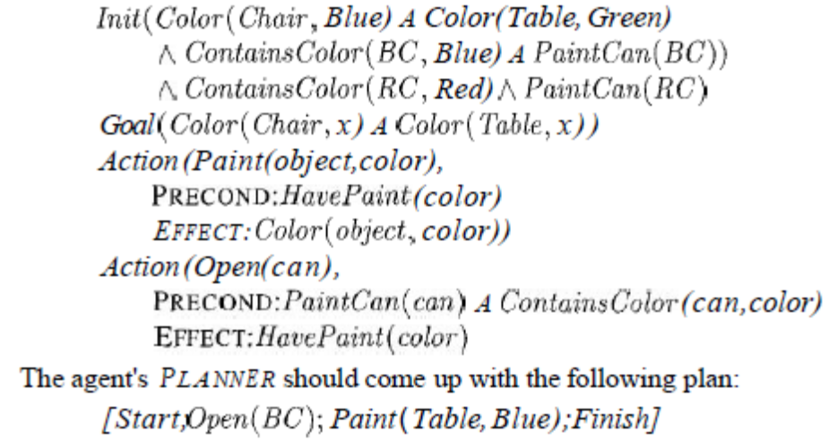
- With this new plan in place, execution monitoring resumes, and the Paint action is retried.
- This behavior will loop until the table is perceived to be completely painted. But notice that the loop is created by a process of plan-execute-replan, rather than by an explicit loop in a plan.
- Action monitoring is a very simple method of execution monitoring but it can sometimes lead to less than intelligent behavior.
- Action monitoring would not detect failure until after the chair has been painted, at which point HavePaint(Red) becomes false.What we really need to do is detect failure whenever the state is such that the remaining plan no longer works.
- Plan monitoring achieves this by checking the preconditions for success of the entire remaining plan-that is, the preconditions of each step in the plan, except those preconditions that are achieved by another step in the remaining plan.
- Plan monitoring cuts off execution of a doomed plan as soon as possible, rather than continuing until the failure actually occurs.
- It is relatively straightforward to modify a planning algorithm so that it annotates the plan at each point with the preconditions for success of the remaining plan.
- If we extend plan monitoring to check whether the current state satisfies the plan preconditions at any future point, rather than just the current point, then plan monitoring will also be able to take advantage of serendipity-that is, accidental success.
- We have described monitoring and replanning in fully observable environments.
- Things can become much more complicated when the environment is partially observable.
- First, things can go wrong without the agent's being able to detect it.
- Second, "checking preconditions" could require the execution of sensing actions, which have to be planned for either at planning time, which takes us back to conditional planning, or at execution time.
- In the worst case, the execution of a sensing action could require a complex plan that itself requires monitoring and hence further sensing actions, and so on.

We have described a method for monitoring and replanning, we need to ask, "Does it work?" This is a surprisingly tricky question. If we mean, "Can we guarantee that the agent will always achieve the goal, even with unbounded indeterminacy?" then the answer is no, because the agent could inadvertently arrive at a dead end.
- If we assume that the environment is really nondeterministic, in the sense that such a plan always has some chance of success on any given execution attempt, then the agent will eventually reach the goal.
- The replanning agent therefore has capabilities analogous to those of the conditional planning agent.
- In fact, we can modify a conditional planner so that it constructs only a partial solution plan that includes steps of the form "if <test> then plan-A else replan."
- Trouble occurs when the agent's repeated attempts to reach the goal are futile-when they are blocked by some precondition or effect that it doesn't know about.
- One solution is to choose randomly from among the set of possible repair plans, rather than trying the same one each time.
- Given that the agent might not be able to distinguish between the truly nondeterministic case and the futile case, some variation in repairs is a good idea in general.

